VLOOKUP:
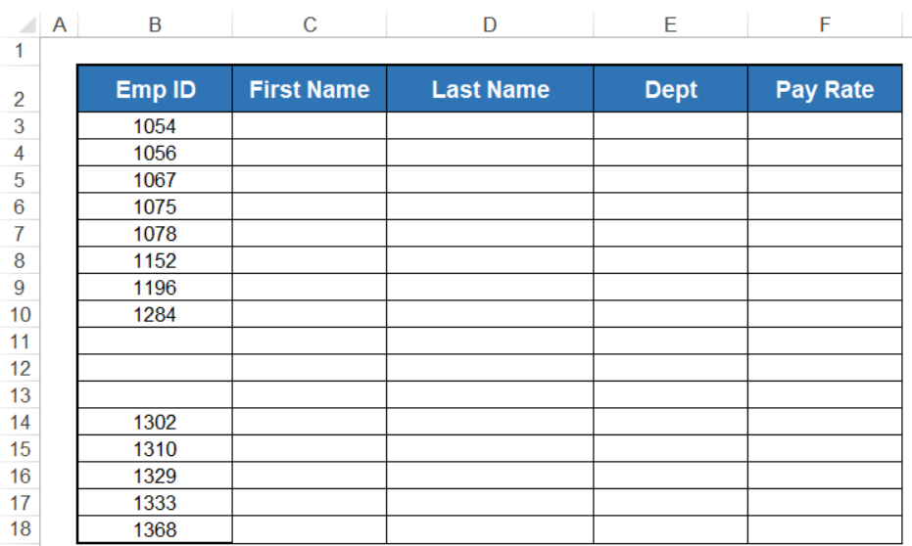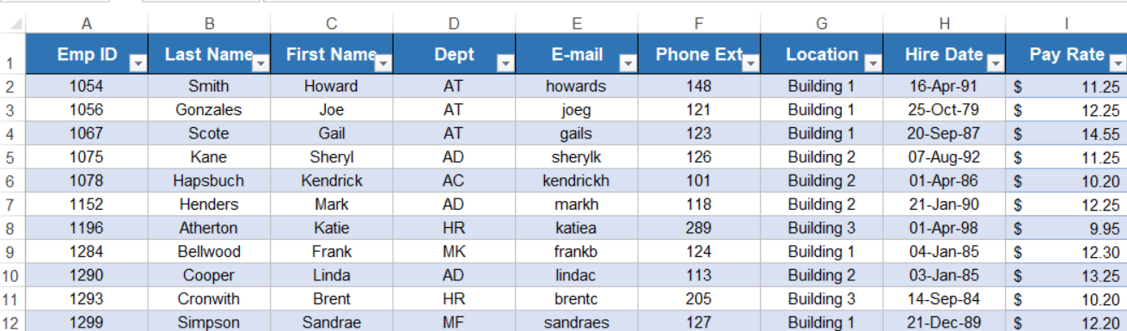

FirstName= =IFERROR(VLOOKUP([@[Emp ID]],MasterList,3,FALSE),"No Matching ID")
LastName=IFERROR(VLOOKUP([@[Emp ID]],MasterList,2,FALSE),"No Matching ID")
Department =IFERROR(VLOOKUP([@[Emp ID]],MasterList,4,FALSE),"No Matching ID")
Pay Rate =IFERROR(VLOOKUP([@[Emp ID]],MasterList,9,FALSE),"No Matching ID")

